ASSIGNMENT – 4
Q1. Write a select command that produces the order number, amount, and date for all rows in the Orders.
Ans. SELECT ONUM, AMT, ODATE FROM ORDERS;

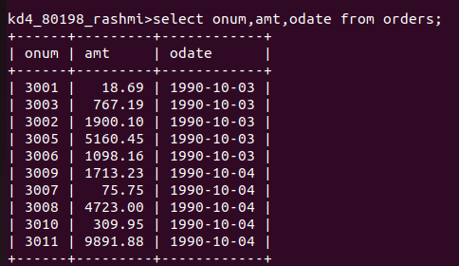

Q2. Write a query that produces all rows from the Customers table for which the salesperson’s number is 1001.
Ans. SELECT * FROM CUSTOMERS WHERE SNUM = 1001;

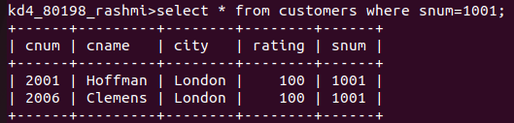

Q3. Write a query that displays the Salespeople table with the columns in the following order: city, sname, snum, comm.
Ans. SELECT CITY, SNAME, SNUM, COMM FROM SALESPEOPLE;

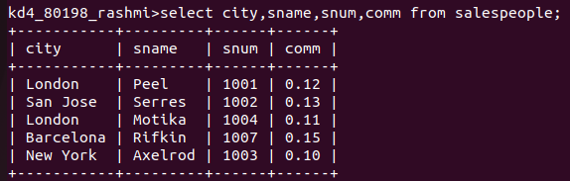

Q4. Write a select command that produces the rating followed by the name of each customer in San Jose.
Ans. SELECT RATING, CNAME FROM CUSTOMERS
WHERE CITY = ‘San Jose’;

